**Module-4 Assessment(SQL)**

* Consider a database containing two tables named as Customer and Salesman.

🡪First Thing Create Database Name =Assessment

* Query: create database assessment.

🡪Then use database :-

* Query: use assessment.

-------------------------------------------------------------------------------------

* For this you need to create a Salesman table:-

🡪Query:

Create table salesman(salesman_id int primary key,name varchar(20),city varchar(20),commission varchar(10))

🡪 After Execute this query Table create successfully.

-------------------------------------------------------------------------------------

* For this you need to create a Customer table:-

🡪Query:

Create table customer(customer_id int primary key,

Cust_name varchar(20),city varchar(20),grade varchar(10),salesman_id int,foreign key(salesman_id) references

salesman (salesman_id))

🡪After Execute this query Table create successfully.

-------------------------------------------------------------------------------------

* First We Can Enter The Data in Salesman Table:

🡪insert into salesman values(5001,”James Hoog”,”New York”,”0.15”), (5002,”Nail Knite”,”Paris”,”0.13”), (5003,”Lauson Hen”,”San Jose”,”0.12”), (5005,”Pit Alex”,”London”,”0.11”),

(5006,”Mc Lyon”,”Paris”,”0.14”), (5007,”Paul Adam”,”Roem”,”0.13”)

🡪After this Query Execute data insert in table successfully.

🡪Now Check The data Of Salesman Table:-

Query:- Select * from salesman

🡪Then You Show This Type of Output:-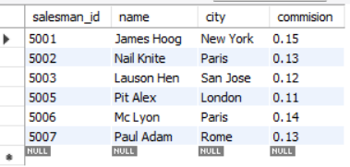

-------------------------------------------------------------------------------------

* First We Can Enter The Data in Customer Table:

🡪insert into customer values(3001,”Brad Guzan”,”London”,””,5005), (3002,”Nick Rimando”,”New York”,”100”,5001), (3003,”Jozy Altidor”,”Moscow”,”200”,5007),

(3004,”Fabian Johnson”,”Paris”,”300”,5006), (3005,”Graham Zusi”,”California”,”200”,5002), (3007,”Brad Davis”,”New York”,”200”,5001), (3008,”Julian Green”,”London”,”300”,5002), (3009,”Geoff Cameron”,”Berlin”,”100”,5003)

🡪After this Query Execute data insert in table successfully.

🡪Now Check The data Of Salesman Table:-

Query:- Select * from customer

🡪Then You Show This Type of Output:-

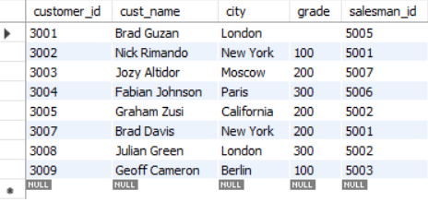

-------------------------------------------------------------------------------------

* From the above given tables write a SQL query to find the salesperson(s) and the customer(s) represented here. Return the Customer Name, City, Salesman, commission.

Query:-

select cust_name,customer.city,commision from salesman inner join customer on salesman.salesman_id=customer.salesman_id

------------------------------------------------------------------------------------

🡪Then You Show This Type of Output:-

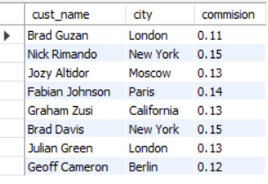

-------------------------------Complete----------------------------------------